[](https://www.iq-test.net/)

**Alpha High IQ Society**

iqtest***A***.com

**[IQ TEST](https://www.iq-test.net/free-iq-test.html)**

**[IQ RECRUITMENT](https://www.iq-test.net/free-iq-test-recruitment.html)**

**[HIGH RANGE IQ](https://www.iq-test.net/high-range-iq-test.html)**

**[EQ TEST](https://www.iq-test.net/eq-test.html)**

**[MBTI TEST](https://www.iq-test.net/16-personality-test-mbti.html)**

**[LOGIC GAMES](https://www.iq-test.net/funny-logic-game/)**

© iqtestA.com

Copyright © Alpha High IQ Society.  
All Rights Reserved.

[DMCA.com Protection Status](https://www.dmca.com/Protection/Status.aspx?ID=ee0bf264-9ff0-423c-9793-9a07869b692c&refurl=https://www.iq-test.net/iq-test-with-answers-42.html)

**[Home](https://www.iq-test.net/)**

**[IQ Test Free](https://www.iq-test.net/iq-test-with-answers-42.html)**

**[EQ Test](https://www.iq-test.net/eq-test.html)**

**[MBTI Test](https://www.iq-test.net/16-personality-test-mbti.html)**

**[What is IQ?](https://www.iq-test.net/what-is-iq.html)**

**[IQ Scores](https://www.iq-test.net/iq-scores.html)**

**[Famous People's IQ](https://www.iq-test.net/iq-test-famous-people.html)**

**[IQ Information](https://www.iq-test.net/news-iq.html)**

**[High IQ Members](https://www.iq-test.net/iq-test-high-members.html)**

take-iq-test-online-free

**[HOME](https://www.iq-test.net/)**

**[IQ TEST FREE](https://www.iq-test.net/free-iq-test.html)**

**[IQ TEST RECRUITMENT](https://www.iq-test.net/free-iq-test-recruitment.html)**

**[IQ TEST HIGH RANGE](https://www.iq-test.net/high-range-iq-test.html)**

**[EQ TEST](https://www.iq-test.net/eq-test.html)**

**[MBTI TEST](https://www.iq-test.net/16-personality-test-mbti.html)**

**[LOGIC GAMES](https://www.iq-test.net/funny-logic-game/)**

**[WHAT IS IQ?](https://www.iq-test.net/what-is-iq.html)**

**[IQ SCORES](https://www.iq-test.net/iq-scores.html)**

**[IQ INFORMATION](https://www.iq-test.net/news-iq.html)**

**[FAMOUS PEOPLE'S IQ](https://www.iq-test.net/iq-test-famous-people.html)**

**[HIGH IQ MEMBERS](https://www.iq-test.net/iq-test-high-members.html)**

​IQ TEST WITH ANSWERS

The IQ test with 10 questions and answers which give you a clear explanation so that you can revise for a real IQ test.

[**IQ TEST QUESTIONS**](http://www.iq-test.net/)

**1. 1, 3, 5, 7, 8, 9, 11 – which one doesn’t belong to this series?**  
**2. Which one of the five is least like the other four?**

1. Dog
2. Mouse
3. Lion
4. Snake
5. Elephant

**3. 29, 27, 24, 20, 15,… What is next?**

1. 7
2. 9
3. 10
4. 11

**4. Which one of the 5 choices makes the best comparison? PEACH is to HCAEP as 46251 is to:**

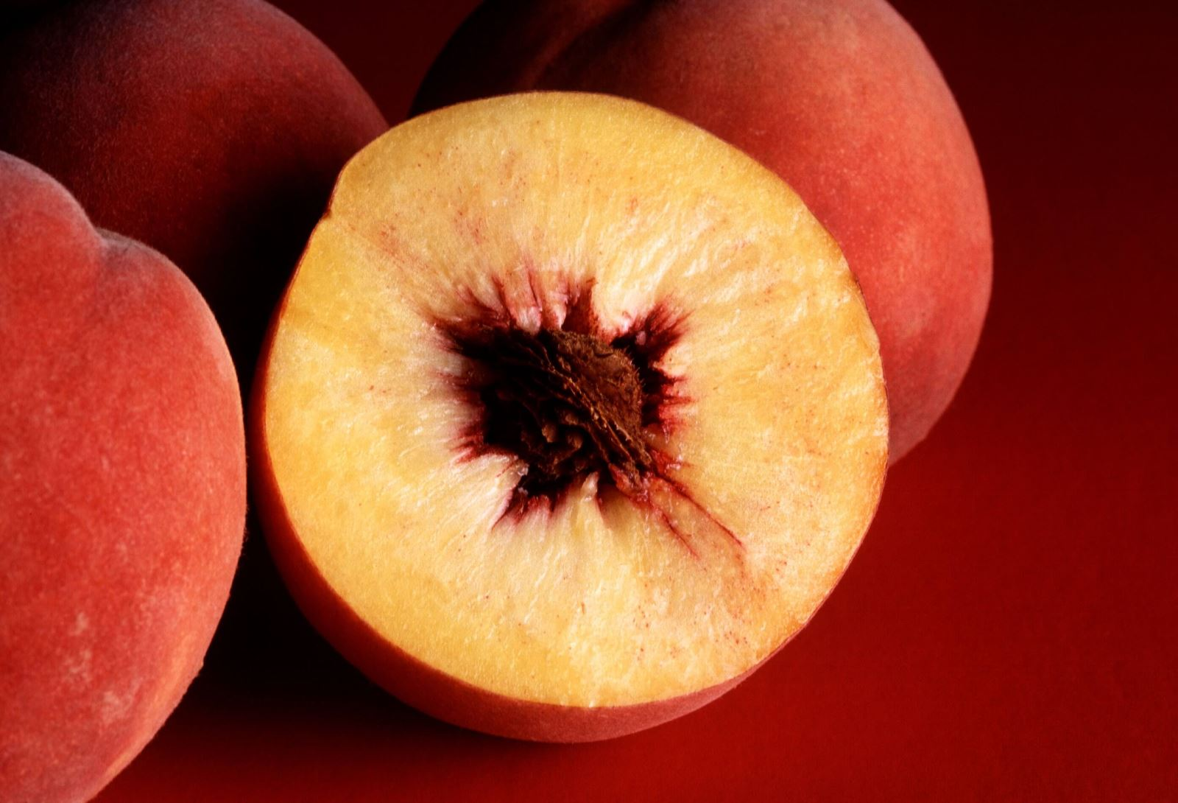

1. 25641
2. 26451
3. 12654
4. 51462
5. 15264

**5. 2, 10, 12, 60, 62, 310… What is next?**

1. 312
2. 360
3. 1550
4. 4650

**6.**

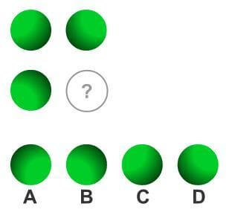

**7. If all Bloops are Razzies and all Razzies are Lazzies, then all Bloops are definitely Lazzies?**

1. True
2. False

**8. 2, 4, 8, 16, 32, 64… What is next?**

1. 90
2. 100
3. 140
4. 256
5. 128

9.  **Mary, who is 16 years old, is four times as old as her brother. How old will Mary be when she is twice as old as her brothers?**



1. 20
2. 24
3. 25
4. 26
5. 28

**10. 121, 144, 169, 196… What is next?**

1. 225
2. 260
3. 298
4. 310

**ANSWERS FOR ABOVE QUESTIONS**

**1. 8**– the series is made up of odd numbers.  
  
**2. Snake** – it has no legs  
  
**3. 9** – the different between numbers in the series increments by 1 each time:29 minus 27 is 2  
27 minus 24 is 3  
24 minus 20 is 4  
20 minus 15 is 5  
The last number in the series is 15 minus 6 = **9**  
  
**4. 15264** – reversing the order of the letters in PEACH gives you HCAEP. So, reversing the numbers 46251 gives you 15264.  
  
**5. 312**- This series of numbers alternates between multiplying by 5 and adding 2:2 x 5 = 10  
10 + 2 = 12  
12 x 5 = 60  
60 + 2 = 62  
62 x 5 = 310  
Finally, 310 + 2 = 312  
  
**6. A** - The three balls form a square with the missing ball. The balls are brighter towards the corners of the square.  
  
**7.True**  
  
**8. 128** – this series is based on multiplying by 2 each time2 x 2 = 4  
2 x 4 = 8  
2 x 8 = 16  
2 x 16 = 32  
2 x 32 = 64  
Finally, 2 x 64 = 128  
  
**9. 24**– if Mary is currently 16, her brother is currently 16 divided by 4 = 4.This makes Mary 12 years older than her brother.  
So, Mary will be double her brother’s age when he is 12.  
  
**10. 225** – in this series, the numbers are squares11 x 11 = 121  
12 x 12 = 144  
13 x 13 = 169  
14 x 14 = 196  
The next number in the series would be 15 x 15 = **225**  
   
[BEST FREE IQ TEST WITH MINI QUIZ FOR ADULTS - <http://bit.ly/2vthBo2>]

5 (100%) 42 votes

Maybe you are interested

**[WHAT IS THE LOWEST IQ EVER?](https://www.iq-test.net/what-is-the-lowest-iq-ever-140.html)**

**[WHAT IS THE AVERAGE IQ OF A DOCTOR?](https://www.iq-test.net/what-is-the-average-iq-of-a-doctor-139.html)**

**[6 ​FAMOUS PEOPLE WITH VERY HIGH IQ](https://www.iq-test.net/6-famous-people-with-very-high-iq-138.html)**

**[​CELEBRITY IQ WILL SURPRISE YOU](https://www.iq-test.net/celebrity-iq-will-surprise-you-137.html)**

**[IQ RESEARCH SHOWS WHAT AREAS IQ TEST CAN MEASURE](https://www.iq-test.net/iq-research-shows-what-areas-iq-test-can-measure-136.html)**

**[SEVEN HABITS OF HIGH EMOTIONAL INTELLIGENCE PEOPLE](https://www.iq-test.net/seven-habits-of-high-emotional-intelligence-people-135.html)**